Use the [GridWorld Quick Reference](https://secure-media.collegeboard.org/apc/ap_comp_sci_a_quick_reference.pdf) if needed.Test the code out during and after each step to make sure it is error free

**\*\*\* Critters will NEVER override the ACT method \*\*\***

**Description:**

The ChameleonCritter class defines a new type of critter that gets the same neighboring actors as a Critter. However, unlike a Critter, a ChameleonCritter processes actors by randomly selecting one and if it is a Rock it will eat it and change to its color. The ChameleonCritter class also overrides the makeMove method of the Critter class. When a ChameleonCritter moves, it turns toward the new location.

**/*~~~~~~~~~~~~~~~~ ChameleonCritterRunner.java ~~~~~~~~~~~~~~~~*/**

**Part 0:**

Create a new Class named ChameleonCritterRunner w/ a main method

In the main method create a new world that uses the code below.

Code to use in the main:

ActorWorld world = new ActorWorld( new BoundedGrid<Actor>(5,5));

// add actors to the world here

world.show();

**\*\* Test part 0 out before moving on to part 1 \*\***

**/*~~~~~~~~~~~~~~~~ ChameleonCritter.java ~~~~~~~~~~~~~~~~*/**

**Part 1:**

Create a new Class named ChameleonCritter, make it extend Critter

Go to the ChameleonCritterRunner and add a default ChameleonCritter to the location (2,2)

Add 8 Rocks of different colors and 4 flowers placed at different Locations, and 2 Actors

New Classes/Methods to use:

extends Critter

world.add( Location loc, Actor actor )

new Location( int row, int col )

new ChameleonCritter( ), new Rock( Color color ), new Flower( Color color ),

new Actor()

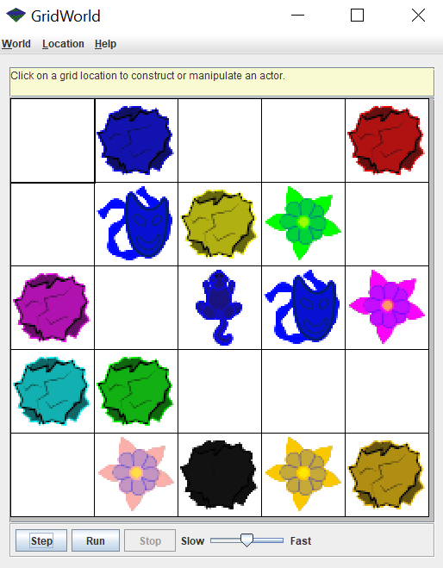

**\*\* Test Part 1 out before moving on to part 2 \*\***

**Part 2:**

Override the processActors method from the Critter class.

Using the given ArrayList of Actors, actors, pick a random actor from the list and print it.

New Classes/Methods to use:

public void processActors( ArrayList<Actor> actors )

Math.random()

System.out.println( )

**\*\* Test Part 2 out before moving on to part 3 \*\***

**Part 3:**

Instead of printing the actor each time, set the color of the ChameleonCritter to the random actor that you pick.

New Classes/Methods to use:

getColor()

setColor( Color newColor )

**\*\* Test part 3 out before moving on to part 4 \*\***

**Part 4:**

Now test if the actor chosen is a Rock. If it is you want to change to its color, then remove the Rock from the grid.

New Classes/Methods to use:

instanceof

removeSelfFromGrid

**\*\* Test part 4 out before moving on to part 5 \*\***

**Part 5:**

Override the makeMove method from the Critter class.

Each time the ChameleonCritter moves it needs to turn to face the direction that it moves to. You will also still need to have the ChameleonCritter move to the random location like in the makeMove method from Critter.

New Classes/Methods to use:

setDirection()

getLocation()

*returns the direction that is pointing toward the location given*/

getDirectionToward( loc ) /

makeMove( loc )

**\*\* Test part 5 out before turning it in \*\***